**Helping Hands**

Deliverable 5

5/9/2019

Anusha Malla

Briana Jenkins

Daniel Bae

Haythem Abdelkhalek

Trmnit Tesfatsion

Wonjin (James) Choi

IS 436 - Structured Systems Analysis and Design

**Interface Structure Diagram**

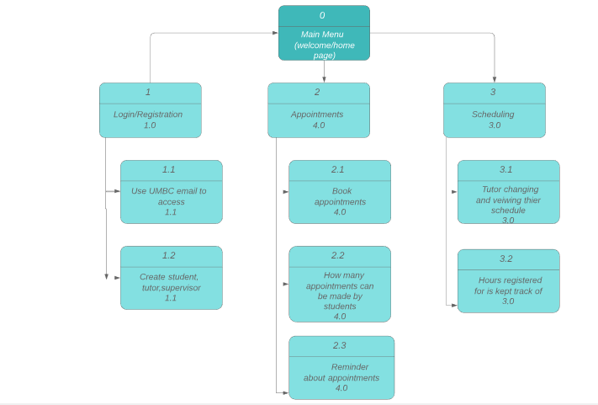

**Interface Standards**

Interface standards are comprised of the basic design elements that are common across the individual screens, forms, and reports within the system. The following selected standards will ensure that the interfaces are consistent across the system.

1. **Interface Metaphor** - a concept from the real world that is used as a model for the information system.
2. Login/ register metaphor: this will be used to symbolize access management software for the app
3. Calendar metaphor: this will be used to symbolize previous and future appointments that student and tutors register for.
4. **Interface Objects and Actions** - fundamental building blocks of the system such as entities and data stores (objects), and commands employed by users (actions). The objects and actions selected are all more general terms that would be simple enough for the end user to understand.
5. Objects:
   1. Entities: Students, Tutor, Supervisor
   2. Data Stores: Registration, and Scheduling Database
6. Actions:
   1. “Login” - allows all to get into the app
   2. “Booked Sessions” - allows for the tutor to see their appointments they have
   3. “Contact tutor” - allows the student to talk to their tutor when needed
   4. “Contact Support” - allows supervisor, tutor, or student to talk to support if something goes wrong
7. **Interface Icons** - interface objects, actions, and their status made to be meaningful, simple, and clear for the user.
8. Login button - the student, tutor, ad supervisor will be able to click it once their information is put in
9. **Interface Templates** - General appearance of all interface components in the information system. This will be used to tie together all of the other major interface design elements. Our team will be proposing the use of the app through appetize.io, which allows you to run the app on another browser. This particular software interface of the app consists of online appointment making and event scheduling between the student and tutor. The interface will combine all of the metaphors, icons, actions, and objects listed above. Most importantly, the interface must ensure user consistency throughout the system.

**Interface Prototypes**

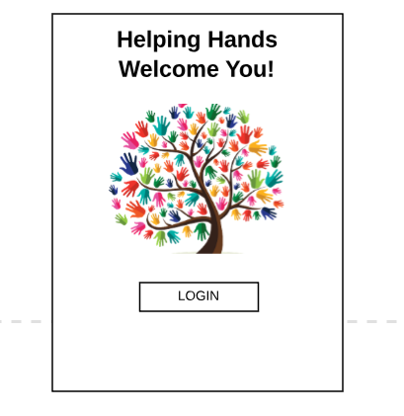

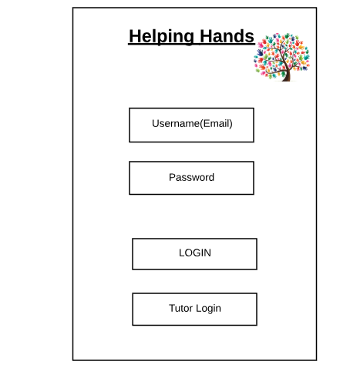

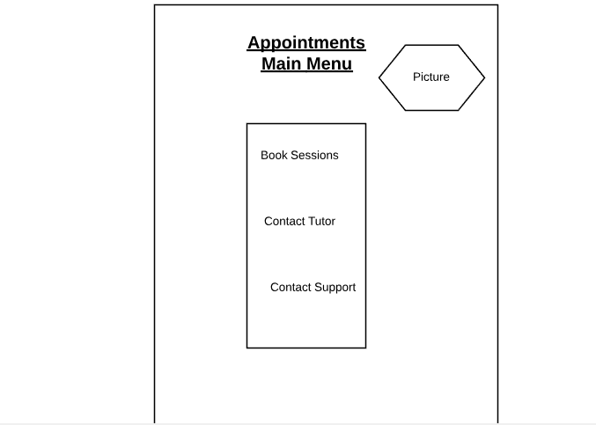

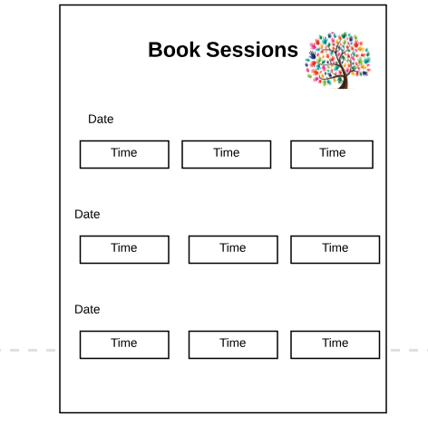

System Requirements

*(to see code of app look at attachment of Code_Helping Hands Folder)*

For implementing the app project, we used android studios and java as the programming language. From there we were able to design the interface design of each page and then coded the code that works between all pages. The hardware aspect was not too much used, but the software part was because the android studios software had to be downloaded but did not need any extras, like USB ports or SD cards.

The only requirements that are needed is a phone preferably a “smart phone.” Most “smartphones” have the necessary requirements to run an app and that is how our program is run. In addition, because it is an android app, it can only run on phones that are android.

Team Experience

The team experience throughout the SDLC process was great. We all were able to put our thoughts and heads together to come up with and solve the problem by going through the steps of SDLC. Also we analyzed the process it would take to finish the app and how it would be done. The designing part did not give us an issue, just figuring out which important screens we were going to focus on took a little time. Overall, the cycle helped the group because it helped us focus on one part of the project at a time. As a team, working together in this project has been very rewarding since we get to learn about the SDLC know how to work in an Agile environment.

KanbanFlow:

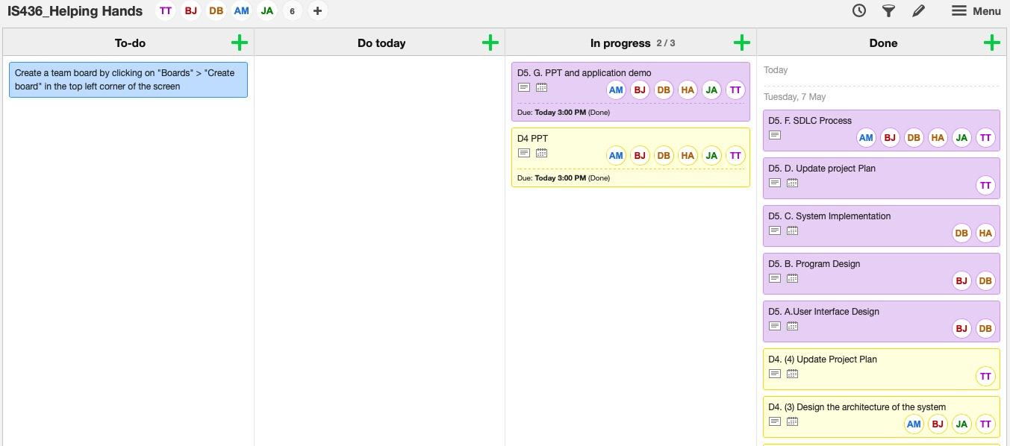

**Updated Gantt Chart:**

(look for attachment D5-Gantt chart_Helping Hands)

